Applecross Senior High School

Semester One Examination, 2018

Question/Answer booklet

MATHEMATICS

SOLUTIONS
METHODS
UNIT 1

Section One:

Calculator-free

Student number: In figures

In words

Your name

Time allowed for this section
Reading time before commencing work: five minutes
Working time: fifty minutes

Materials required/recommended for this section
To be provided by the supervisor
This Question/Answer booklet
Formula sheet

To be provided by the candidate
Standard items: pens (blue/black preferred), pencils (including coloured), sharpener,
correction fluid/tape, eraser, ruler, highlighters

Special items: nil

Important note to candidates
No other items may be taken into the examination room. It is your responsibility to ensure that you do not have any unauthorised material. If you have any unauthorised material with you, hand it to the supervisor before reading any further.

Structure of this paper

Section | Number of questions available | Number of questions to be answered | Working  time (minutes) | Marks available | Percentage of examination
Section One:  Calculator-free | 8 | 8 | 50 | 52 | 35
Section Two:  Calculator-assumed | 13 | 13 | 100 | 98 | 65
 |  |  |  | Total | 100

Instructions to candidates

1. The rules for the conduct of examinations are detailed in the school handbook. Sitting this examination implies that you agree to abide by these rules.

2. Write your answers in this Question/Answer booklet.

3. You must be careful to confine your response to the specific question asked and to follow any instructions that are specified to a particular question.

4. Supplementary pages for the use of planning/continuing your answer to a question
have been provided at the end of this Question/Answer booklet. If you use these pages to continue an answer, indicate at the original answer where the answer is continued, i.e. give the page number.

5. Show all your working clearly. Your working should be in sufficient detail to allow your answers to be checked readily and for marks to be awarded for reasoning. Incorrect answers given without supporting reasoning cannot be allocated any marks. For any question or part question worth more than two marks, valid working or justification is required to receive full marks. If you repeat any question, ensure that you cancel the answer you do not wish to have marked.

6. It is recommended that you do not use pencil, except in diagrams.

7. The Formula sheet is not to be handed in with your Question/Answer booklet.

Section One: Calculator-free 35% (52 Marks)
This section has eight (8) questions. Answer all questions. Write your answers in the spaces provided.

Working time: 50 minutes.

Question 1 (5 marks)
(a) Solve $5\left(2t+1\right)-3\left(t-4\right)=0$ for $t$. (2 marks)

Solution
$$10t+5-3t+12=0 \\ 7t+17=0$$

$$t=-\frac{17}{7}$$

Specific behaviours
expands and simplifies correctly
solves for $t$

(b) Solve $\begin{matrix}7 \\ \overline{a-5}\end{matrix}-\begin{matrix}3 \\ \overline{4a}\end{matrix}=0$ for $a$. (3 marks)

Solution
$$\begin{matrix}7 \\ \overline{a-5}\end{matrix}=\begin{matrix}3 \\ \overline{4a}\end{matrix}⇒28a=3\left(a-5\right)$$

$$28a=3a-15 \\ 25a=-15$$

$$a=-\frac{15}{25}=-\frac{3}{5}$$

Specific behaviours
cross-multiplies
expands and simplifies
solves for $a$

Question 2 (5 marks)
Solve the following equations.

(a) $6x^{2}=3x$. (2 marks)

Solution
$$3x\left(2x-1\right)=0$$

$$x=0, x=\frac{1}{2}$$

Specific behaviours
equates to zero and factorises
solutions

(b) $x\left(x+2\right)=24$. (3 marks)
Solution
$$x^{2}+2x-24=0$$

$$\left(x+6\right)\left(x-4\right)=0$$

$$x=-6, x=4$$

Specific behaviours
expands and equates to zero
factorises
solutions

Question 3 (6 marks)
A function is defined by $f\left(x\right)=\sqrt{3x}$.

(a) Calculate $f(12)$. (1 mark)
Solution
$$f\left(12\right)=\sqrt{36}=6$$

Specific behaviours
correct value

(b) State the domain and range of $f(x)$. (2 marks)

Solution
$$D_{f}:x≥0, R_{f}:f(x)≥0$$

Specific behaviours
domain, range

(c) Sketch the graph of $y=f(x)$ on the axes below. (3 marks)

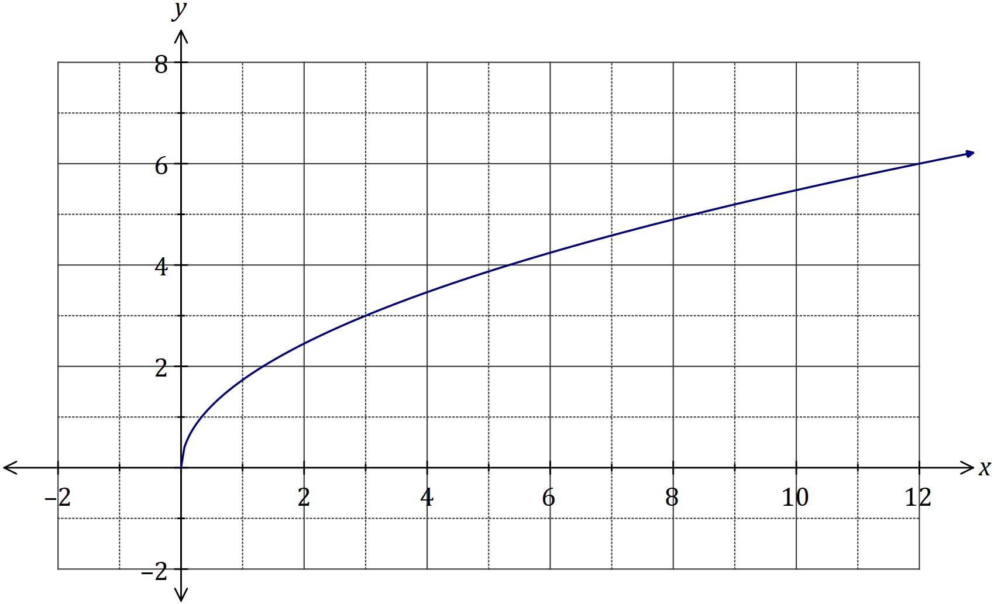
Solution
See graph
Specific behaviours
starts at (0,0)
passes through (3, 3) and (12, 6)
smooth curve

Question 4 (5 marks)
The graph of the line $L_{1}$ is shown below.

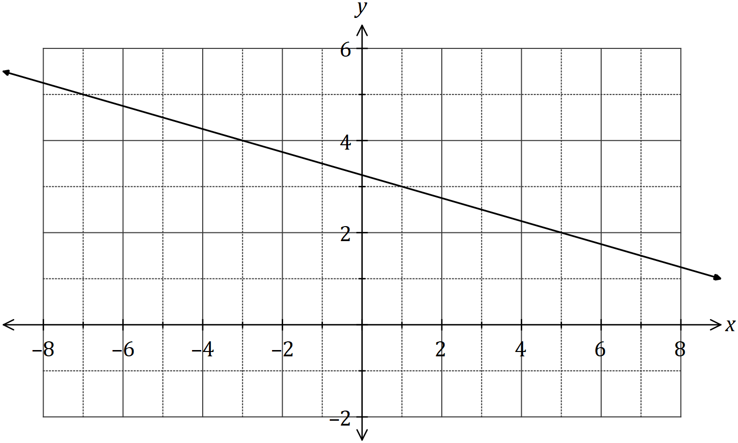

(a) Determine the equation of $L_{1}$. (2 marks)
Solution
$$m=-\frac{1}{4}$$

$$y-3=-\frac{1}{4}(x-1) \\ y=-\frac{1}{4}x+\frac{13}{4}$$

Specific behaviours
gradient
correct equation (any form)

Two points are located at $A(-10, 5)$ and $B(6, 29)$.

(b) Line $L_{2}$ is perpendicular to $L_{1}$ and passes through the mid-point of $A$ and $B$. Determine the equation of $L_{2}$. (3 marks)
Solution
$$M\left(-2, 17\right)$$

$$m=-1÷\left(-\frac{1}{4}\right)=4$$

$$y-17=4\left(x-\left(-2\right)\right) \\ y=4x+25$$

Specific behaviours
coordinates of midpoint
perpendicular gradient
equation of line (any form)

Question 5 (6 marks)
(a) Expand and simplify $(x+2)(2x-5)(x-2)$. (2 marks)

Solution
$$\left(x+2\right)\left(2x-5\right)\left(x-2\right)=\left(2x-5\right)\left(x^{2}-4\right)$$

$$=2x^{3}-{5x}^{2}-8x+20$$

Specific behaviours
expands one pair of terms
simplified expansion

(b) One solution to the equation $x^{3}+36=5x^{2}+12x$ is $x=2$. Determine all other solutions.
(4 marks)
Solution
$$x^{3}-5x^{2}-12x+36=0$$

$$\left(x-2\right)\left(x^{2}+ax-18\right)=0$$

$$-2+a=-5⇒a=-3$$
$$\left(x-2\right)\left(x^{2}-3x-18\right)=0$$

$$\left(x-2\right)\left(x-6\right)\left(x+3\right)=0$$
$$\text{Other solutions: }x=6, x=-3$$

Specific behaviours
equates to zero and identifies $(x-2)$ as a factor
factors out quadratic expression
identifies value of $a$
factors quadratic and states other two solutions

Question 6 (9 marks)
(a) Solve the equation $\sqrt{3}\tan{(x)}-3=0$ for $0≤x≤2π$. (3 marks)
Solution
$$\tan{x}=\frac{3}{\sqrt{3}}=\sqrt{3}$$
$$x=\frac{π}{3},\frac{4π}{3}$$

Specific behaviours
expression for $\tan{x}$
one solution
second solution (penalise once for use of degrees)

(b) A function has a period of $k$ and is defined by $f\left(x\right)=4\cos{(2x)}$.

(i) State the value of $k$. (1 mark)
Solution
(i) $k=\frac{2π}{2}=π \text{or} k=\frac{360}{2}=180°$

(ii) Amplitude is $4$

Specific behaviours
period (either unit)
amplitude

(ii) State the amplitude of $f(x)$. (1 mark)

(iii) Sketch the graph of $y=f(x)$ over the domain $-k≤x≤k$. (4 marks)

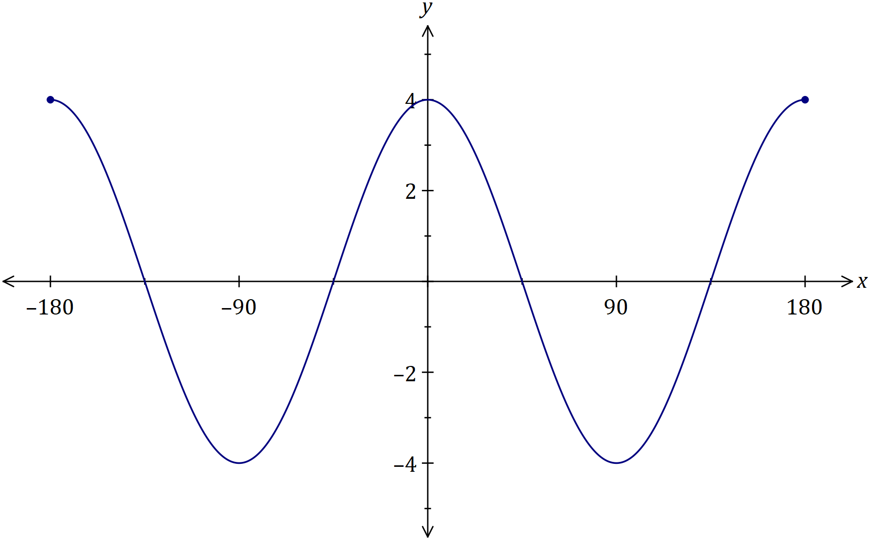
Solution
See graph (student choice of radians or degrees)
Specific behaviours
amplitude correct, with scale indicated
axes intercepts, with scale indicated
two complete cycles (no penalty for slightly exceeding domain
smooth curve

Question 7 (9 marks)
(a) Determine the coordinates of the $y$-axis intercept of the line $3x+5y-11=0$. (2 marks)
Solution
$$x=0, 5y-11=0⇒y=\frac{11}{5}$$
$$\left(0,\frac{11}{5}\right)≡(0, 2.2)$$

Specific behaviours
simplifies by substituting $x=0$
correct coordinates

(b) A quadratic function is given by $y=(x-1)(x+4)$. For the graph of this function, determine

(i) the coordinates of the $y$-axis intercept. (1 mark)
Solution
$$x=0, y=\left(-1\right)\left(4\right)=-4$$

$$\left(0, -4\right)$$
Specific behaviours
correct coordinates

(ii) the coordinates of the zeros (ie the $x$ intercepts). (2 marks)
Solution
$$y=0⇒x=1, -4$$

$$\left(1, 0\right)\text{ and }\left(-4, 0\right)$$

Specific behaviours
indicates zeros
writes as coordinates

(iii) the equation of the axes of symmetry. (2 marks)
Solution
$$x=\frac{1+\left(-4\right)}{2}=-\frac{3}{2}$$

$$x=-1.5$$
Specific behaviours
averages zeros
writes as equation

(iv) the coordinates of the turning point. (2 marks)
Solution
$$y=\left(-1.5-1\right)\left(-1.5+4\right) \\ =-2.5×2.5=-\frac{5}{2}×\frac{5}{2}=-\frac{25}{4}$$

$$\left(-1.5, -6.25\right)≡\left(-\frac{3}{2}, -\frac{25}{4}\right)$$

Specific behaviours
substitutes $x$-coordinate
correct coordinates

Question 8 (7 marks)
(a) The graph of the relation $y^{2}=x$ passes through the points $\left(16,a\right)$ and $(b, -5)$. Determine the values of $a$ and $b$. (3 marks)
Solution
$$a^{2}=16⇒a=4, a=-4$$

$${\left(-5\right)}^{2}=b⇒b=25$$

Specific behaviours
one value of $a$
both values of $a$
value of $b$

(b) Another relation is defined by ${\left(x-1\right)}^{2}+{\left(y+2\right)}^{2}=4$.

(i) Sketch the graph of this relation on the axes below. (3 marks)

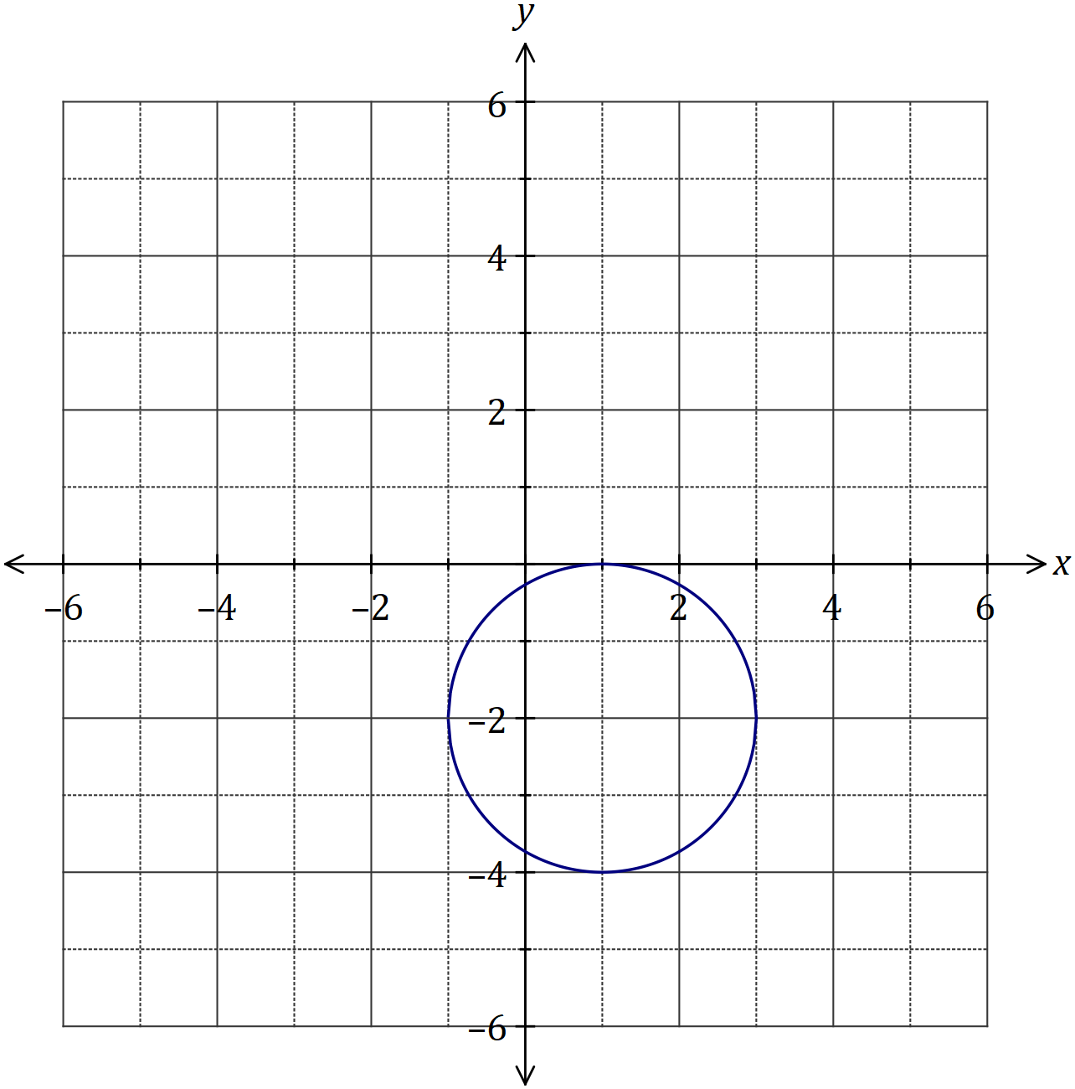
Solution
See graph
Specific behaviours
centre
radius
reasonably smooth circle

(ii) What feature of the graph indicates that a relation rather than a function is shown? (1 mark)
Solution
A vertical line can be drawn that intersects the circle more than once, and thus shows a relation.

Specific behaviours
uses vertical line test

Supplementary page

Question number: _________

© 2018 WA Exam Papers. Applecross Senior High School has a non-exclusive licence to copy and communicate this document for non-commercial, educational use within the school. No other copying, communication or use is permitted without the express written permission of WA Exam Papers. SN002-112-2.

